# 3 Design

## 3.1 Design Context

### 3.1.1 Broader Context

Describe the broader context in which your design problem is situated. What communities are you designing for? What communities are affected by your design? What societal needs does your project address?

Ames and the surrounding area. With 5G implemented, it allows for many low power user devices to be connected to the internet in a large area. 5G will provide fast, reliable internet connection for many different use cases.

List relevant considerations related to your project in each of the following areas:

| **Area** | **Description** | **Examples** |
| --- | --- | --- |
| Public health, safety, and welfare | It gives rural area citizens access to 5G wireless for agricultural use. | Increases agricultural production around the Ames area benefiting agricultural workers. |
| Global, cultural, and social | Our project involves finding users to deploy UEs in people’s environments.  Box production in China as cheaper materials | User’s displeasuring of deploying 5G equipment in a lot of areas in their community. |
| Environmental | No real environmental effects. Base stations use some energy and the enclosure is printed out of plastic. | Mass production of enclosures may lead to a lot of waste when/if discarded |
| Economic | Increases the rural economy. | More sophisticated wireless tech deployed in agriculture, ie autonomous tractors.  Better wireless access to rural communities which increases connectivity and educational opportunities. |

### 3.1.2 User Needs

Rural communities need a better way to connect to the internet because existing infrastructure is lacking. 5G provides a faster and more stable connection than existing tech nologies.

Industrial and agricultural industries can benefit from increased connectivity by deployment of 5G technologies. Connected devices like various sensors for soil, plants, etc require a solid internet connection.

Hospitals, police, and first responders also benefit from increased connectivity.

### 3.1.3 Prior Work/Solutions

<https://book.systemsapproach.org>: Covers general information about computer networking.

<https://5g.systemsapproach.org> : This book provides background information on 5G architectures, which helps develop a baseline understanding of the technology.

<https://www.ece.iastate.edu/~hongwei/group/publications/PRKS-TWC.pdf>: Paper written by faculty adviser that explains the per-packet delivery reliability method. This reliability measure is used as a constraint on network communications.

### 3.1.4 Technical Complexity

Provide evidence that your project is of sufficient technical complexity. Use the following metric or argue for one of your own. Justify your statements (e.g., list the components/subsystems and describe the applicable scientific, mathematical, or engineering principles)

Our design contains many devices that we have to account for which are described in section 3.3. We have to be able to make holders for these devices within the enclosure so that they do not move through different measurements such as thickness of material based on device size and holder sizes. Another piece of the project that is down the road is modifying srsRAN algorithms to schedule packets for maximum network reliability.

## Design Exploration

### 3.2.1 Design Decisions

List key design decisions (at least three) that you have made or will need to make in relation to your proposed solution. These can include, but are not limited to, materials, subsystems, physical components, sensors/chips/devices, physical layout, features, etc.

1. Need to decide what material the final enclosure will be made of.
2. Need to decide an efficient way to enclose the physical components including the NUC, amplifier, and SDRs.
3. Need to decide an efficient power supply to power the components

### 3.2.2 Ideation

For one design decision, describe how you ideated or identified potential options (e.g., lotus blossom technique). List at least five options that you considered.

- When thinking of potential materials to build our enclosure out of, we have to think about the environment that the enclosure will be in. Since this enclosure will be outside, we need a material that can’t be easily deteriorated and can protect the in

side components against the weather.

-Options: 3D printing filament, Steel, Aluminum, Wood, fiberglass,

### 3.2.3 Decision-Making and Trade-Off

Demonstrate the process you used to identify the pros and cons or trade-offs between each of your ideated options. You may wish you include a weighted decision matrix or other relevant tool. Describe the option you chose and why you chose it.

-In our process to identify the pros and cons of each material, we mainly focused on 1. the cost of the material 2. how easy it is to manufacture. 3. How well it holds up against outside weather conditions.

We decided to choose 3D printing filament at the beginning of this project in order to first get a prototype of the enclosure we want to build. 3D printing is cheap and we can test a lot of different designs without it being too expensive.

## Proposed Design

Discuss what you have done so far – what have you tried/implemented/tested?

-We decided that we should design and build a prototype enclosure with 3D printing as a cheap way to make sure our measurements are right and everything fits. Once we have a design finalized, we can send off the design to a 3rd party company to produce that box in metal.

### 3.3.1 Design Visual and Description

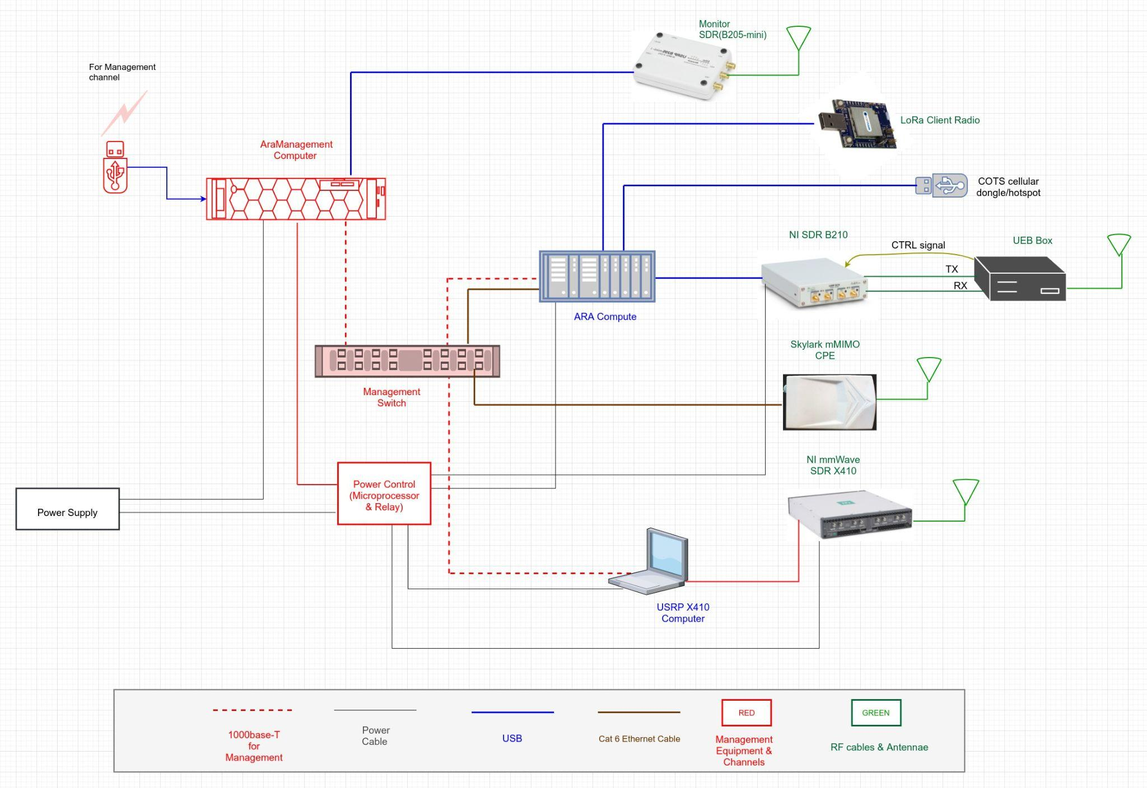

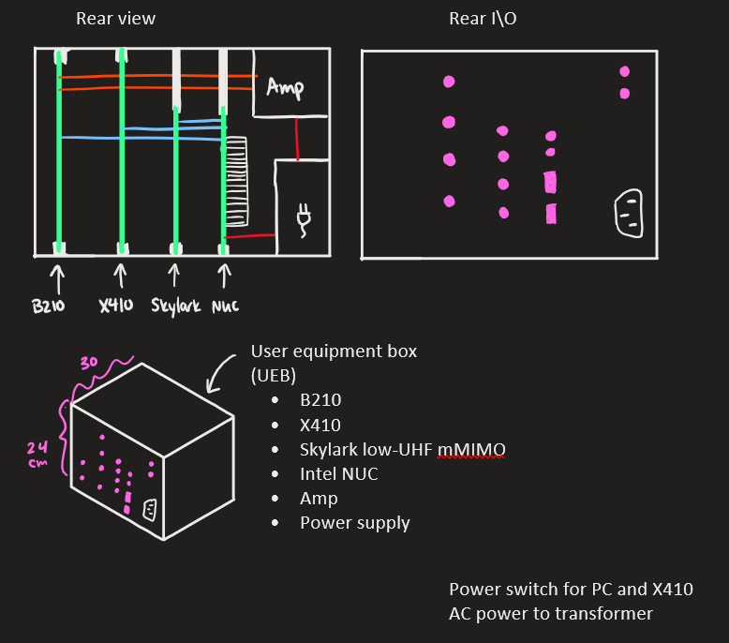Our current design for an enclosure has to fit all the necessary components being 3 SDRs, the computer, an amplifier, and a power supply. This enclosure is going to have slots for each PCB of the SDR and computer to slide into which makes it very modular. The back of the enclosure will have IO for every component. The amplifier is used to transmit the signal from the B210 SDR to the base station. The design will have perforations in the side allowing for airflow and the computer will have a fan for additional cooling. The SDRs will communicate and be powered via USB to the computer. The srsRAN will run on the SDRs and base stations enabling them to communicate with each other. This software can be modified to affect the performance and properties of the SDRs.

### 3.3.2 Functionality

This enclosure is going to be able to be deployed anywhere with access to power. It will sit all on its own with the desired hardware and communicate with a nearby base station. The user will not need to modify the enclosure or mess with anything inside for it to work properly. Our current design allows for different SDRs to be put in the enclosure making it modular and fit many different use cases.

### 3.3.3 Areas of Concern and Development

Based on your current design, what are your primary concerns for delivering a product/system that addresses requirements and meets user and client needs?

-The design should suit the user and client situation. And the enclosure should have stable performance and effectiveness. On the product side, we try to reduce the cost of the product, and the product also should be easily accessible.

What are your immediate plans for developing the solution to address those concerns? What questions do you have for clients, TAs, and faculty advisers?

-Our immediate plans are to start 3D modeling the enclosure and researching srsRAN open-source software.

## **NOTE: The following sections will be included in your final design document but do not need to be completed for the current assignment. They are included for your reference. If you have ideas for these sections, they can also be discussed with your TA and/or faculty adviser.**

## 3.4 Technology Considerations

Highlight the strengths, weaknesses, and trade‐offs made in technology available.

Discuss possible solutions and design alternatives

## 3.5 Design Analysis

–  Did your proposed design from 3.3 work? Why or why not?

–  What are your observations, thoughts, and ideas to modify or iterate over the design?

## Design Plan

Describe a design plan with respect to use-cases within the context of requirements, modules in your design (dependency/concurrency of modules through a module diagram, interfaces, architectural overview), module constraints tied to requirements.